Ghana

## Freedom House political status

The data set shows the Freedom House political scores and status of the country each year.

## # A tibble: 19 x 5  
## country iso3c date mean status   
## <chr> <chr> <dbl> <dbl> <chr>   
## 1 Ghana GHA 1996 3.5 Partly Free  
## 2 Ghana GHA 1998 3 Partly Free  
## 3 Ghana GHA 2000 2.5 Free   
## 4 Ghana GHA 2002 2.5 Free   
## 5 Ghana GHA 2003 2 Free   
## 6 Ghana GHA 2004 2 Free   
## 7 Ghana GHA 2005 1.5 Free   
## 8 Ghana GHA 2006 1.5 Free   
## 9 Ghana GHA 2007 1.5 Free   
## 10 Ghana GHA 2008 1.5 Free   
## 11 Ghana GHA 2009 1.5 Free   
## 12 Ghana GHA 2010 1.5 Free   
## 13 Ghana GHA 2011 1.5 Free   
## 14 Ghana GHA 2012 1.5 Free   
## 15 Ghana GHA 2013 1.5 Free   
## 16 Ghana GHA 2014 1.5 Free   
## 17 Ghana GHA 2015 1.5 Free   
## 18 Ghana GHA 2016 1.5 Free   
## 19 Ghana GHA 2017 1.5 Free

## Freedom House classification of political change

The data set shows the GDP growth and the ecomic growth classification of the country each year.

## # A tibble: 19 x 4  
## country iso3c date politicalChangeFH  
## <chr> <chr> <dbl> <chr>   
## 1 Ghana GHA 1996 no change   
## 2 Ghana GHA 1998 no change   
## 3 Ghana GHA 2000 democratization   
## 4 Ghana GHA 2002 no change   
## 5 Ghana GHA 2003 democratization   
## 6 Ghana GHA 2004 no change   
## 7 Ghana GHA 2005 democratization   
## 8 Ghana GHA 2006 no change   
## 9 Ghana GHA 2007 no change   
## 10 Ghana GHA 2008 no change   
## 11 Ghana GHA 2009 no change   
## 12 Ghana GHA 2010 no change   
## 13 Ghana GHA 2011 no change   
## 14 Ghana GHA 2012 no change   
## 15 Ghana GHA 2013 no change   
## 16 Ghana GHA 2014 no change   
## 17 Ghana GHA 2015 no change   
## 18 Ghana GHA 2016 no change   
## 19 Ghana GHA 2017 no change

## Freedom House score trend

The plot shows the Freedom House scores trend of the country.

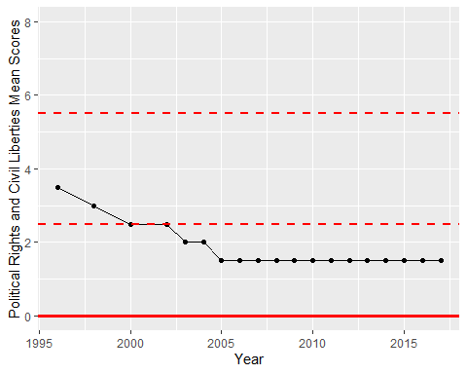

Freedom House Score Trend